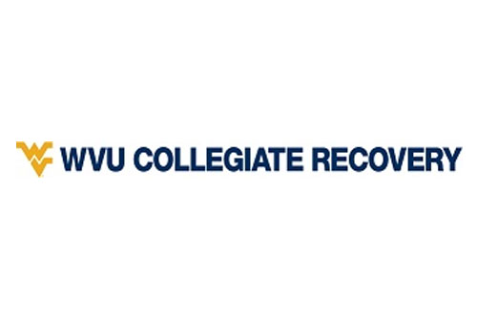
A Community Resource Guide for Addiction and Mental Health Services for Students

WVU Resources
WVU Collegiate Recovery

Website: https://recovery.wvu.edu/contact-us
Contact Information: Director Olivia Pape, olivia.pape@mail.wvu.edu
Location: 628 Price St. Morgantown, WV 26505

Description: The WVU Collegiate Recovery Program (CRP) supports students in recovery by promoting a healthy, balanced, and meaningful life on campus. Through activities centered around health, wellness, adventure, community, service, and fun, the WVU CRP's goal is to provide the support and resources necessary for students to thrive in their recovery and develop meaning and purpose as they move forward in life.

Services: We offer a variety of group meetings and events. We have “All” Recovery meetings and SMART meetings for those in recovery from substance use disorders, eating disorders, and mental disorders. We have a ton of events throughout each semester that offer a supportive and sober environment for students. We have a house in Arnold Hall and a virtual platform that students can join at any time, even if they just want to talk or do homework.
Admission Criteria: Individuals just have to be a WVU student

Referral Process: No referrals needed. You can show up at any time as long as we are open

Helpful Information from Agency: Our team consists of some of the nicest and most supportive people in the community. We will welcome all students with open arms no matter what the situation is.

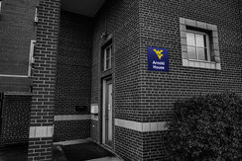

Collegiate Recovery Resources
WV Collegiate Recovery Network

Phone: (304) 614-7177
Websites: https://www.marshall.edu/crn/ or https://www.facebook.com/CRNWV/

Description: The West Virginia Collegiate Recovery Network is an innovative partnership, offering peer recovery support services on seven higher education campuses. This project is supported by federal State Opioid Response funding, which originates from the federal Substance Abuse and Mental Health Services Administration.

Services: Ally trainings, Naloxone training, mindfulness and meditation, SMART Recovery, SMART Recovery for Family and Friends, Depression and Bipolar Support, All Recovery Meetings, and more

Admission Criteria: Must be a community resident, student, faculty, staff, or friend/family member

Referral Process: No referral process – can find contact information on website to get started

Helpful Information from Resource: “The West Virginia Collegiate Recovery Network (WVCRN) is a resource for information, training and technical assistance for any West Virginia college or university that wants to create a recovery community. Through support, education and campus advocacy, we aim to create an inclusive environment and supportive community to help students, faculty and staff thrive.”

Other Collegiate Recovery Resources
The Association of Recovery in Higher Education (ARHE)

Website: https://collegiaterecovery.org/

Description: The ARHE is the only association exclusively representing collegiate recovery programs and collegiate recovery communities, the faculty and staff who support them, and the students who represent them. ARHE provides the education, resources, and the community connection needed to help change the trajectory of recovering student’s lives.

WVU Resources
West Virginia University (WVU) Student Assistance Program (SAP), Substance Use/Misuse

Phone: (304)-293-4431
Location: WVU Carruth Center, 390 Birch St. Morgantown, WV

Description: This resource located is at the WVU Carruth Center. Students can reach out to the Carruth Center for any psychological or psychiatric reason. For the Student Assistance Program (SAP) specifically, the main portion is mandated programming. This program serves students who are sanctioned or in community-based programs on drug or alcohol related instances. Students can come through residence life, student conduct, or the magistrate court. Students may also contact this resource on their own if interested.

Services: WVU’s Student Assistance Program offers an array of services for students with alcohol or other drug concerns, including individual assessment, individual and group counseling, and educational activities. Students who seek our services participate in an evaluation/assessment, which is reviewed by the SAP staff.

Admission Criteria: Must be a WVU student registered for classes

Referral Process: Self-Referral or Referral from residence life, student conduct, or magistrate court

Helpful Information from Resource: “Please do not be afraid to shoot Missy Pforr (missy.pforr@mail.wvu.edu) or myself, Fanica Payne (fpayne1@mail.wvu.edu), an email and do not hesitate to call the Carruth Center.”

WVU Resources
WVU Medicine Center for Hope and Healing

Phone: (304)-971-3100 Morgantown Location (Receptionist won’t know specifics about program information) or (681)-342-3360 Bridgeport Location

Location: 751 Benefactor Drive, Morgantown, WV 26501 (Adjacent to Mylan Park)

Description: The WVU Medicine Center for Hope and Healing supports adults struggling with substance use disorders through medically managed withdrawal stabilization and residential treatment.

Services: Inpatient Treatment only, this resource offers a 28-day detox residential stay for substance use disorders. Both locations offer medicated-assisted treatment, family support services, individualized treatment plans, trauma-informed care, mindfulness-based practices, specialized programming for recent overdose survivors and pregnant women.

Admission Criteria: Must be an adult with a substance use disorder

Referral Process: Providers may refer a patient through our online referral portal or use a referral form. Patients may also self-refer. Must complete a form and may email completed form to hope@wvumedicine.org, or fax it to their number listed. You may find the referral form at https://wvumedicine.org/hope/

Helpful Information from Resource: “Patients must have insurance. It is suggested to call your insurance company to see if it is in network with Hope and Healing.”

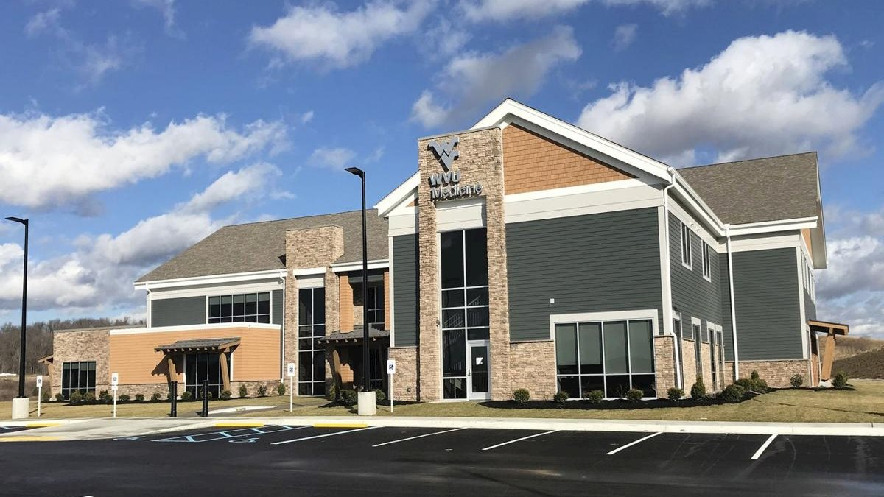

WVU Resources
WVU Medicine Dual Diagnosis Unit

Phone: (304) 598-6400 (This number will just be for scheduling an appointment)
Location: WVU Medicine Chestnut Ridge Center – 930 Chestnut Ridge Rd. Morgantown

Description: This is an inpatient dual diagnosis detoxification and treatment unit. There are 10 beds on the unit and the average length of stay is 5 days. Patients with both substance use disorders, and co-occurring psychiatric disorders are treated. *May be a long wait list*

Services: Patients come for detox purposes from substances, they will see a multidisciplinary team that consists of psychologists, psychiatrists, doctors, social workers, and more. This agency offers care for severe mental illness. The dual diagnosis unit offers assessment and treatment planning of the patient.

Admission Criteria: Patients must enter through the emergency department (ER) all across the state and be 18+ years old. When they enter through the ER, they must have a Blood Alcohol Level of less than 300 and experiencing severe mental health issues that alter their everyday life.

Referral Process: Self-Referral by entering through the emergency department and saying you need to detox while also explaining your mental health symptoms.

Helpful Information from Resource: “The most important thing is letting people know the process of how to get into our unit. Just go through the emergency department and they will help start the process.”

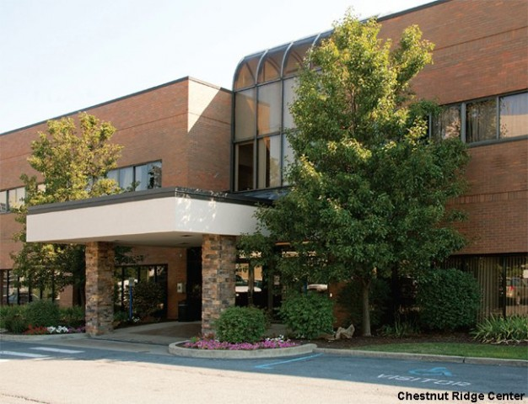

WVU Resources
WVU Comprehensive Opioid Addiction Treatment (COAT)

Phone: (304) 598-6400 (This number will just be for scheduling an appointment)
Location: WVU Medicine Chestnut Ridge Center – 930 Chestnut Ridge Rd. Morgantown

Description: We believe that healing from the disease of addiction includes abstinence from alcohol and all other drugs of use. Recovery also requires an active recovery program that includes behavioral and cognitive changes. *May be a long wait list*

Services: Intensive Outpatient Program for individuals and family therapy. This is a behavioral medicine facility that works on a weekly basis with patients. Participants attend two appointments during each visit that consist of medical management and group therapy sessions. Participants are required to attend a minimum four hours’ worth of recovery meetings per week. For the first 90 days of treatment. Patients must come at least once a week for medication therapy and individual therapy by a psychiatrist.

Admission Criteria: Must undergo a drug and alcohol intake assessment that is 2 hours long to see if COAT is the right program for you.

Referral Process: Doctor referral or self-referral through the emergency department. A team of psychiatrists will meet with you and it should take 2-3 weeks to get you into the COAT program.

Helpful Information from Resource: “The COAT program is very flexible and will work with you. There are group meetings at any time of the day and there is absolutely no pressure to start medicated assisted treatment (MAT) if that is something you are considering.”

Community Resources
West Virginia Sober Living

Phone: (304) 413-4300
Location: 206 Spruce St, Morgantown, WV 26505

Description: West Virginia Sober Living’s main goal is reintegrating recovery individuals into the world. Accountability is built into the program and offers residents a safe, caring, and supportive environment to begin living a sober life. There is a women’s home and a men’s home in the Morgantown Area.

Services: This resource is a sober living home that offers transition from treatment back into real life of people that have substance used disorders. This is a 12-step based facility. Weekly 12 step Alcoholics Anonymous and Narcotics Anonymous meetings are held.

Admission Criteria: Must be an adult with a substance use disorder

Referral Process: Referrals from outside treatment or self-referral

Helpful Information from Resource: “We are a 12-step based structured facility environment to help people be successful in life, long term.”

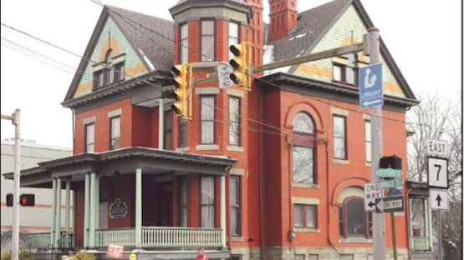

Community Resources
United Summit Center – WVU Neuroscience

Phone: (304) 623-5661
Location: 34 Commerce Dr, Morgantown, WV 26501

Description: United Summit Center (USC) is a comprehensive mental health center serving 6 counties in north central West Virginia. United Summit Center and Chestnut Ridge Center in coordination with WVU Medicine, work together to provide quality behavioral health service to people who have acute and chronic psychiatric disabilities, intellectual/developmental disabilities, substance use disorders, and to people who are in crisis in an effort to assist in the achievement of their fullest potential

Services: Individual therapy (adult and child), family therapy, group therapy, case management, outreach, psychiatric evaluations and medication management, school-based counseling, crisis stabilization residential unit, substance use residential treatment, group SUD treatment, psych evaluations, and more

Admission Criteria: N/A

Referral Process: You can find referral forms and information at https://wvumedicine.org/rni/rni-homepage/refer-a-patient/

Helpful Information from Resource: The leadership at the WVU Rockefeller Neuroscience Institute guides our teams in providing compassionate patient care and advanced medicine through forward-thinking leadership, education, research, and outreach in the many diverse communities we serve. It is this collaborative approach that allows us to offer exceptional patient care in the many unique communities we serve – while maintaining our national and international prominence.

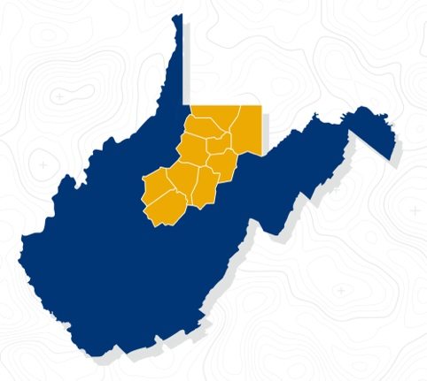

Community Resources
Ascension Recovery Services

Phone: (304) 241-4585
Location: 103 Corporate Drive Ste 102, Morgantown, WV 26501

Description: Ascension Recovery Services offers long-term addiction recovery support services to men and women dealing with substance use issues. These services include addiction interventions, addiction recovery legal services, and relapse prevention and monitoring. Ascension also offers substance use treatment center design and development consulting.

Services: Addiction interventions, family interventions, legal services, consulting services, clinical transportation, clinical counseling, peer recovery coaching, drug and alcohol testing, assessments, treatment planning, and monitoring services.

Admission Criteria: Must be an adult with a substance use disorder. It is preferred that patients already went to detox and treatment prior to entering program because we do not offer clinical detox. We will accept a patient who hasn’t been to treatment though. We do not take individuals with severe behavior or mental health diagnoses.

Referral Process: Self online referral at https://www.ascensionrs.com/contact.html?hsCtaTracking=efb71a3f-8f03-48cb-9342-a6201bc83265%7C67c65ced-f3a6-4a2c-801a-92bd42279387

Helpful Information from Resource: “Go to ascensionrs.com for more information about our services. There is a contact page on there and anyone can contact us.”



Community Resources
WV Peers

Phone: (304) 602-3305
Location: Not one specific location. Many times, WV Peers will work out of WV Sober Living or WVU Medicine and will be out in the community

Description: West Virginia Peers is a network of certified peer recovery coaches in the community working to help connect individuals to the services they need to live a healthier and more fulfilling life. We can help you access several resources in the community and state.

Services: Overdose prevention, naloxone providers, syringe exchange, shelter, food, and/or clothing, medical and mental health care, detox, inpatient and outpatient drug treatment, 12-step programs.

Admission Criteria: Must be someone with a substance use disorder, but not required

Referral Process: No referral needed, just call the number above to get the process started by talking to a recovery coach

Helpful Information from Resource: “We will help you find where you need to go. Please don’t be afraid to call us. Even if you are worried about a loved one or an issue you might have, you can call us for guidance.”

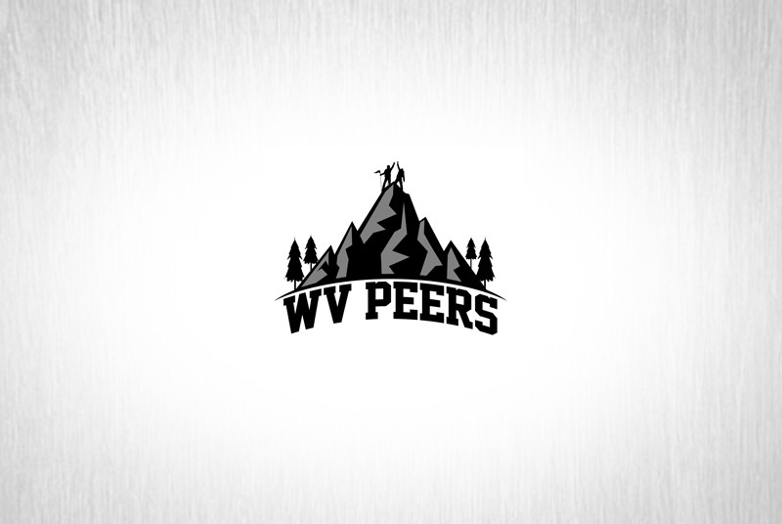

Community Resources
Valley Healthcare System

Phone: (304) 296-1731
Location: Many locations specific to needs. Main office is 301 Scott Avenue, Morgantown, WV 26508

Description: Valley Healthcare System offers many different types of programs for individuals dealing with chemical dependency and mental health issues. Services range from individual appointments to residential services.

Services: Outpatient Services, DUI help, intensive outpatient therapy, crisis units (stable or detox, recovery coaches, 28-day programs, IDD program (intellectually disabled individuals).

Admission Criteria: There are specific admission criteria when considering Valley Healthcare System. Clients must also have some form of insurance to pay for treatment. There are possible grants available to help pay for treatment.

Referral Process: Self-Referral. You can call anytime from Tuesday-Friday. Clients may also walk into clinics to talk to someone. To receive financial aid information, the first available clinician can talk over the phone.

Helpful Information from Resource: “Don’t be afraid to call. Our crisis hotline is (304) 296-1731.”

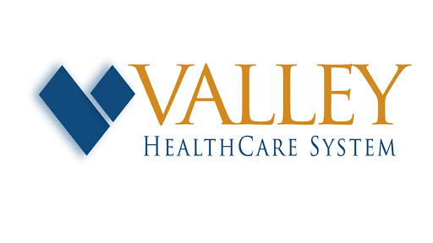

Community Resources
Help4WV
Phone: (844) 435-7498
Website: https://www.help4wv.com/

Description: HELP4WV offers a 24/7 call, chat, and text line that provides immediate help for any West Virginian struggling with an addiction or mental health issues. Many of those answering our accredited helpline are peer-support specialists or recovery coaches. This means that they have personal experience in recovery from a mental health or substance use issue. Whether someone is struggling with a developmental disorder, addiction, or mental health, this help line is available for anyone to use to find treatment.

Services: Confidential support, resource referrals, self-help groups, out-patient counseling, medication-assisted treatment, psychiatric care, emergency care, and residential treatment

Admission Criteria: No criteria

Referral Process: No referral needed, anyone is able to call number or go on website for more contact information

Helpful Information from Resource: “There are many types of treatment available, and we have access to over 1,000 resources. You can use our searchable database to find resources. You can also talk to one of our helpline agents who can guide you to the right place. We know the treatment options can be sometimes overwhelming or confusing.”

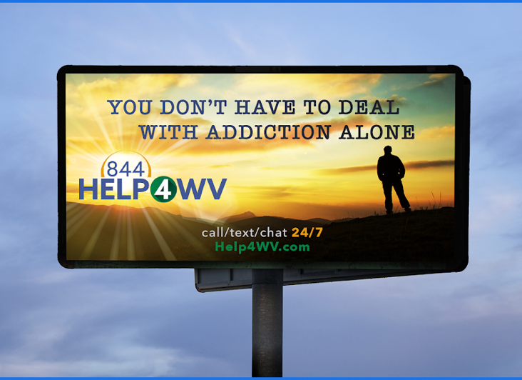

Community Resources
Jacob’s Ladder

Phone: (304) 239-1214
Location: Aurora, WV 26705

Description: Jacob’s Ladder at Brookside Farm is a long-term, residential recovery program. This is a community made up of professionals and peers all striving toward recovery in a supportive environment.

Services: This is a 4–6-month commitment. Services include a personalized addiction treatment model, meditation, mindful farming, lecture/education, 12 step meetings, recreation therapy and individual therapy, group/family therapy, and Jacob’s Laffer Community Meetings. There is also mesic and art programming, wilderness adventure therapy, and more.

Admission Criteria: Upon arrival, they will conduct a biopsychosocial assessment of clients and based on assessment, a personalized addiction treatment plan will be created. You must be 18+ and your insurance must be accepted.

Referral Process: Self-Referral. Contact information can be found on https://www.jacobsladderbrookside.com/

Helpful Information from Resource: “There is a lot of traditional therapy and groups, mindfulness, yoga, meditation, woodshops for crafts and projects, a working farm, and outdoor adventure programs here.”

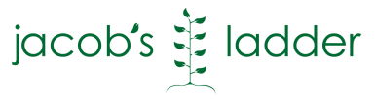

Eating Disorder Support
WVU Disordered Eating Center of Charleston (DECC)

Phone: (304) 388-1000
Location: Charleston, WV
Website: https://www.hsc.wvu.edu/decc/home/

Description: The WVU Disordered Eating Center of Charleston (DECC) was launched in the summer of 2010 by Drs. Stephen Sondike and Jessica Luzier. DECC is an interprofessional outpatient treatment program that provides services for youth and adults with disordered eating and clinical eating disorders

Services: Clinical services are provided at the WVU Department of Behavioral Medicine at CAMC Memorial Hospital. DECC psychotherapists use a variety of modalities in their treatment, including individual, group and family therapy. Therapeutic approaches include Family Based Therapy, Cognitive-Behavioral Therapy-Enhanced, Dialectical Behavior Therapy, and Acceptance and Commitment Therapy. Therapists work in tandem with psychiatrists, general medical practitioners, and a registered dietitian to tailor a treatment plan to each patient.

Admission Criteria/ Referral Process: Referrals may be made by patients/families themselves or by other healthcare providers. Please download and fax the DECC referral located on our website or call the WVU DECC Scheduling Specialist at 304-388-1000.

Helpful Information from Resource: “Awareness and prevention are major commitments for the DECC. Eating disorders remain stigmatizing and shameful. There is an imperative to increase public awareness and provide high fidelity information to counter the myths associated with these perilous medical and psychiatric conditions. One important charge of DECC is public education and awareness.”

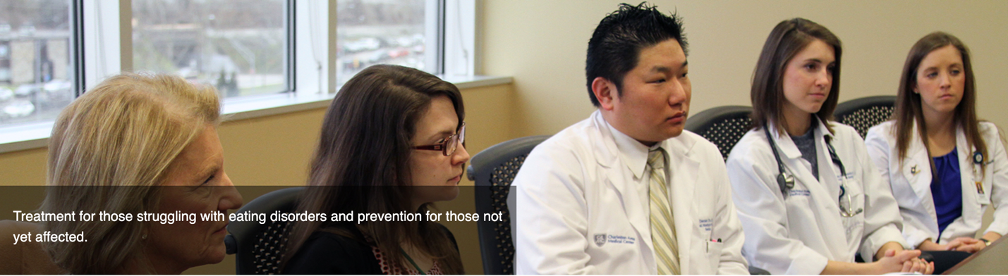

Community Support Groups – 12 Step Based
Mountaineer Region of Narcotics Anonymous

Helpline Number: 1-800-766-4442
Website for meeting schedule: http://mrscna.org/

Information about program: This is a free resource where people can go to in person or virtual meetings. People are allowed to show up at any meetings and participate if they want. NA is a nonprofit fellowship or society of men and women who have had substances become a major problem in their life.

Perspective on sobriety: We do not care what you have done in the past. In our literature is says you’re clean when you say you are clean, which we consider to be complete abstinence

Helpful Information from Resource: “There are some groups in the Morgantown area for students. In general, when you are searching for recovery, you want to find a community of people that can support you through that.”

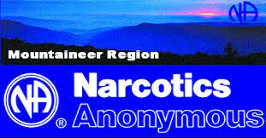

Community Support Groups – 12 Step Based
Alcoholics Anonymous Area 73 District 16

24/7 Hotline Number: (800) 333-5051
Website for meeting schedule: https://www.aawv.org/district-16

Information about program: Participants in AA share their story and personal experience and help support other with their drinking problem. AA helps a person learn how to live a happy life without alcohol and give person-to-person “sponsorship” to the people attending. This resource offers open discussion meetings, open speaker meetings, and closed discussion or group step meetings.

Perspective on sobriety: AA does not provide detox or other medical services and does not force someone to stop drinking. The only requirement to join is the desire to stop drinking. AA’s purpose is to stay sober and help others achieve sobriety as well.

Helpful Information from Resource: “Call our 24-hour, 7-day a week, toll free number shown above.”

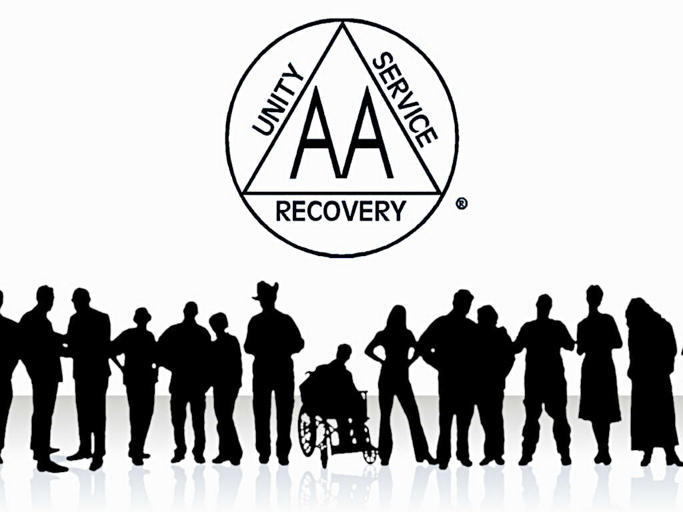

Community Support Groups – 12 Step Based
Al-Anon and Alateen in West Virginia

Phone: (888) 490-1970
Website for Meeting Schedule: https://wvafg.org/afg-meetings

Information about program: “Our personal situations may be different, but we share as equals because of what we have in common: our lives have been affected by another person’s drinking. Al-Anon is a mutual support group. We can find understanding and support when we share our common experience with each other. Some of us are here because a spouse or partner has struggled with alcoholism. For others, the problem drinker is a parent, child, or grandchild. Sometimes a brother, a sister, or some other friend or relative brings us to Al-Anon. Many of us have had more than one alcoholic family member or friend. Alcoholism has similar effects on us all, even though our relationships to the alcoholic may be different. Many newcomers are most interested in hearing about situations and relationships that are similar to their own. Over time, however, we come to understand that we can benefit from hearing how the Al-Anon principles worked in many different circumstances.”
Perspective on sobriety: It doesn’t matter if your loved one is still actively drinking or if they are sober, anyone is still welcomed at any meeting

Helpful Information from Resource: “We are offering help and hope for anyone who has ever been affected by someone else’s drinking.”

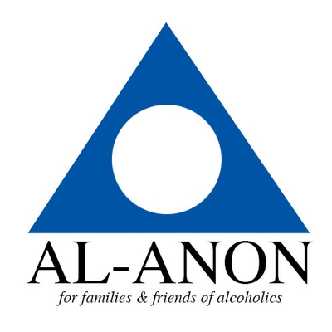

Community Support Groups – 12 Step Based
Celebrate Recovery

Phone: (304) 599-6306
Location: 479 Van Voorhis Rd Morgantown, WV 26505 (There are other locations in the community as well)
Website: Suncrest: https://www.suncrestumc.org/celebrate-recovery/
Main Page: https://www.celebraterecovery.com/

Information about program: Celebrate Recovery is a Christ-centered, 12 step recovery programs for anyone struggling with hurt, pain or addiction

Perspective on sobriety: “True sobriety is more than just physical abstinence from a substance or behavior. We learn to turn our wills and our lives over to God. We learn to give back to others through service. We find that we can only keep what we have by giving it away to others who struggle as we have.”

Helpful information from resource: “Celebrate Recovery is a safe place to find community and freedom from the issues that are controlling our life.”

Community Support Groups – 12 Step Based
Refuge Recovery

Phone: (323) 207-0276 For Morgantown Location
Location: 369 Oakland St. Morgantown, WV 26505
Website: Morgantown: https://www.facebook.com/Refuge-Recovery-MoTown-165499097483558/
Main Page: https://www.refugerecovery.org/

Information about program: We are a peer-led movement using Buddhist-inspired practices and principles, combined with successful recovery community structures, to overcome addiction. We offer recovery from all forms of addiction through participation in the program.

Perspective on sobriety: Abstinence from all recreational mind altering substances

Helpful information from resource: “Members practice daily meditation, mentorship, retreats, and more. Meetings are available in over 500 locations worldwide virtually and in person.”

Virtual Resource Links – COVID-19
Substance Abuse and Mental Health Services Administration: https://www.samhsa.gov/sites/default/files/virtual-recovery-resources.pdf

National Eating Disorder Awareness:
https://www.nationaleatingdisorders.org/help-support/covid-19-resources-page

In the Rooms – A Global Recovery Community:
https://www.intherooms.com/home/

